Use these tables for the SQL/Pandas Questions (from techbeamers.com):

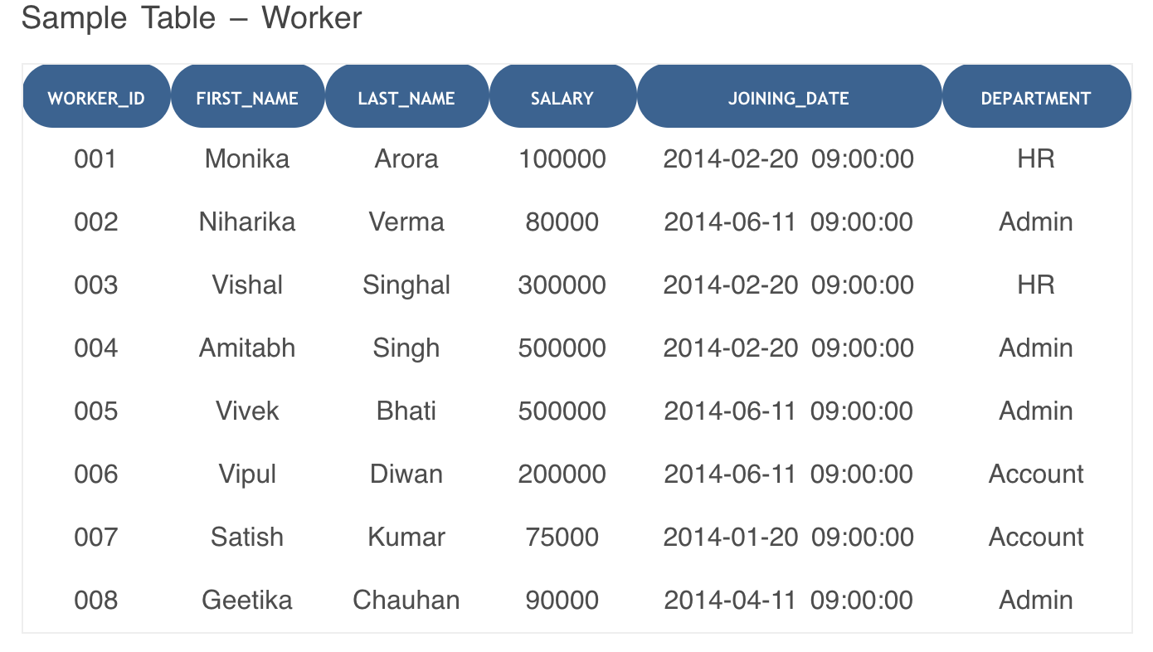

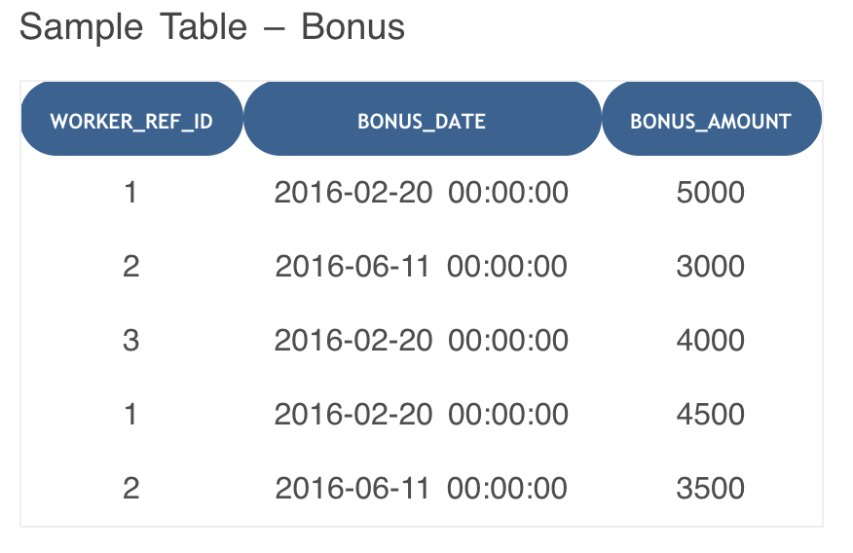

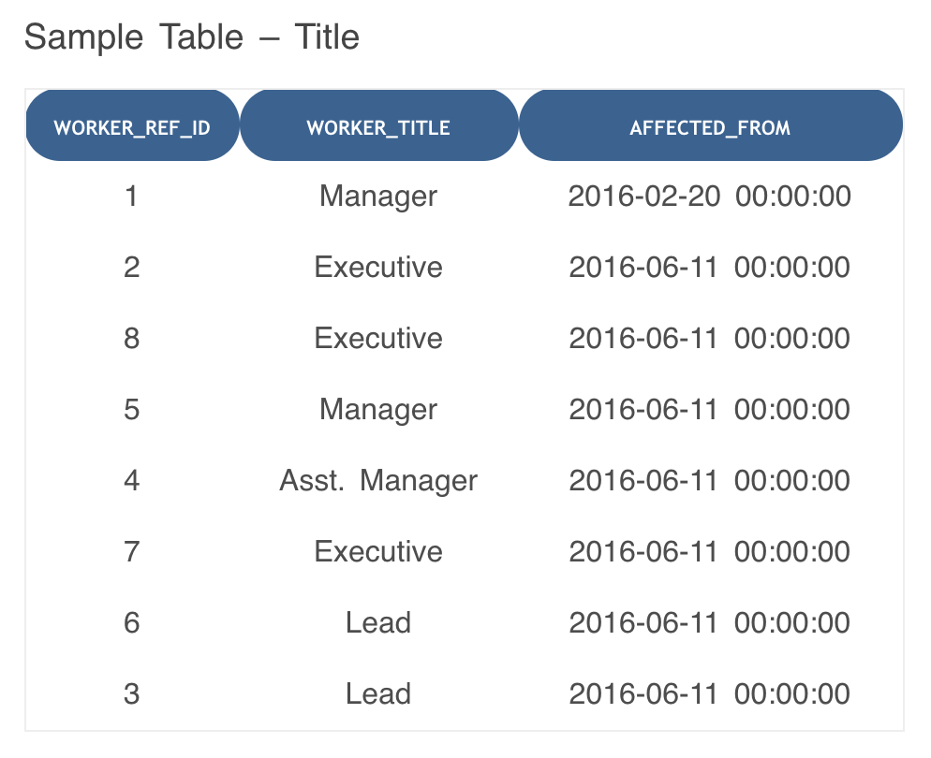

**Q1.** Write An SQL Query To Print The FIRST_NAME And LAST_NAME From Worker Table Into A Single Column COMPLETE_NAME. A Space Char Should Separate Them.

Select CONCAT(FIRST_NAME, ' ', LAST_NAME) AS 'COMPLETE_NAME' from Worker;

**Q2.** Write An SQL Query To Print Details Of The Workers Who Are Also Managers.

SELECT DISTINCT W.FIRST_NAME, T.WORKER_TITLE

FROM Worker W

INNER JOIN Title T

ON W.WORKER_ID = T.WORKER_REF_ID

AND T.WORKER_TITLE in ('Manager');

Chris: I don’t think that this answer is very complete or robust. We should probably update this.

**Q3.** Write An SQL Query To Print The Name Of Employees Having The Highest Bonus In Each Department.

**Coding Questions:**

**Q1.** Given an expression string, write a python program to find whether a given string has balanced parentheses or not. Output should be ‘balanced’ or ‘unbalanced’

Examples of balanced parenthesis: ‘()’, ‘{[()]}’, ‘()()()()()()()’, ‘[[[]]]’, ‘{()}{()}[{}]’

Examples of unbalanced parenthesis: ‘[(])’, ‘{{{}}’, ‘(]’, ‘[(){}(]’

<https://www.geeksforgeeks.org/check-for-balanced-parentheses-in-python/>

**Q2:** Given a string, find the first duplicate word.

Input : "Ravi had been saying that he had been there"

Output : had

Input : "Ravi had been saying that"

Output : No Repetition

Input : "he had had he"

Output : he

<https://www.geeksforgeeks.org/find-first-repeated-word-string-python-using-dictionary/>